Tibial Nerve

חקר העצבים והשרירים ברגליים:  
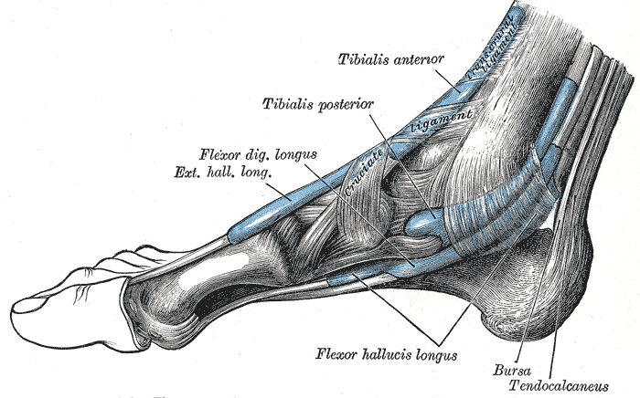

Muscular branches - Muscular branches arises from the distal part of the popliteal fossa. It supplies the medial and lateral heads of [gastrocnemius](https://en.wikipedia.org/wiki/Gastrocnemius), [soleus](https://en.wikipedia.org/wiki/Soleus), [plantaris](https://en.wikipedia.org/wiki/Plantaris) and [popliteus](https://en.wikipedia.org/wiki/Popliteus) muscles. Nerve to popliteus crosses the popliteus muscle, runs downwards and laterally, winds around the lower border of the popliteus to supply the deep (or anterior) surface of the popliteus. This nerve also supplies the [tibialis posterior](https://en.wikipedia.org/wiki/Tibialis_posterior) muscle, [superior tibiofibular joint](https://en.wikipedia.org/wiki/Superior_tibiofibular_joint), [tibia](https://en.wikipedia.org/wiki/Tibia) bone, [interosseous membrane of leg](https://en.wikipedia.org/wiki/Interosseous_membrane_of_leg), and the [inferior tibiofibular joint](https://en.wikipedia.org/wiki/Inferior_tibiofibular_joint).[[1]](https://en.wikipedia.org/wiki/Tibial_nerve#cite_note-BD_Chaurasia-1)

Ventral roots - מכילים את האקסונים של נויירוני התנועה.

Deep peroneal nerve

Muscular branches - supplies four muscles in the leg: [tibialis anterior](https://en.wikipedia.org/wiki/Tibialis_anterior), [extensor hallucis longus](https://en.wikipedia.org/wiki/Extensor_hallucis_longus), [extensor digitorum longus](https://en.wikipedia.org/wiki/Extensor_digitorum_longus), and [peroneous tertius](https://en.wikipedia.org/wiki/Peroneous_tertius)[[1]](https://en.wikipedia.org/wiki/Deep_peroneal_nerve#cite_note-BD_Chaurasia-1)

Muscular branches - supplies four muscles in the leg: [tibialis anterior](https://en.wikipedia.org/wiki/Tibialis_anterior), [extensor hallucis longus](https://en.wikipedia.org/wiki/Extensor_hallucis_longus), [extensor digitorum longus](https://en.wikipedia.org/wiki/Extensor_digitorum_longus), and [peroneous tertius](https://en.wikipedia.org/wiki/Peroneous_tertius)[[1]](https://en.wikipedia.org/wiki/Deep_peroneal_nerve#cite_note-BD_Chaurasia-1)

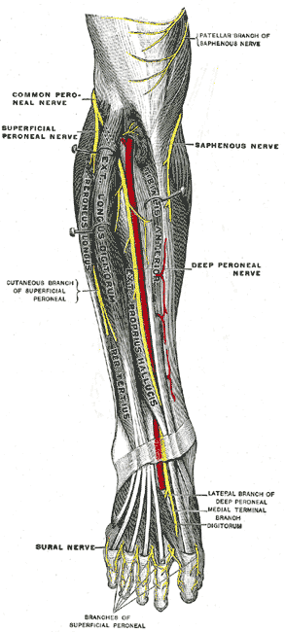

Superficial peroneal nerve

Muscular branches to peroneus longus and peroneus brevis[[1]](https://en.wikipedia.org/wiki/Superficial_peroneal_nerve#cite_note-BD_Chaurasia-1)



מקור של כל המידע הנל: ויקיפדיה

תמונה המראה את השרירים בכף הרגל

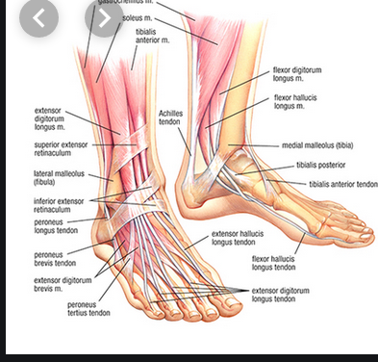

מקור תמונה: <https://healthmaxphysio.com/5-myths-about-foot-and-ankle-injuries/>

